. The specific parameter values are shown in Table 1. The other model parameters are the results of fitting optimization based on the original data.

Table 1 Initial values of the dynamic system

|  |  |  |  |  |
| --- | --- | --- | --- | --- |
| Variable | *S* | *E* | *I* | *Sq* |
| Value | 1.395 billion | 6901 | 776 | 8420 |
| Variable | *Sq* | *Eq* | *H* | *R* |
| Value | 2776 | 500 | I+ *Eq* | 31 |

First of all, under different infectious ability of patients with latent period (=0,0.6,1 ), the corresponding model parameters are obtained by fitting and optimization based on the raw data, and predict the epidemic situation in future. As can be seen from the Fig. 2, the corresponding optimal model parameters are found with different infectious abilities. Under the optimal parameters, the number of infected persons predicted by the theoretical model is in good agreement with the raw data from January 23, 2020 to February 10, 2020. Next, we can analyze the effect of different infectious ability of patients in latent period on model estimation. Note that without considering the infectious capacity of patients in the incubation period, that is, =0 , the present model can degenerate to obtain the recent dynamic model of infectious disease transmission established in Ref.[8]. The results shown in Figure 2 show that the peak estimate of the number of infected people using the theory established in Ref.[8] is much higher than the estimate made by the present theoretical model. This is due to the neglect of the infectious ability of patient in latent period in previous models[6-8]. Because only the infected are transmissible, the actual probability of infection needs to be overestimated to adequately fit the raw data, which ultimately leads to overestimation of the number of infected people.

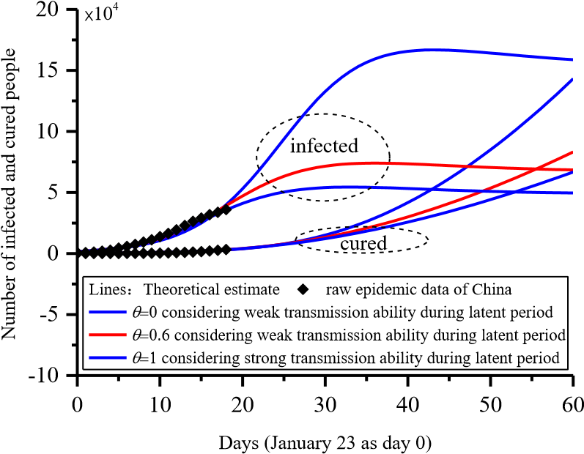

Figure. 2.Effect of infectious ability of patient in latent period on the theoretical estimation.

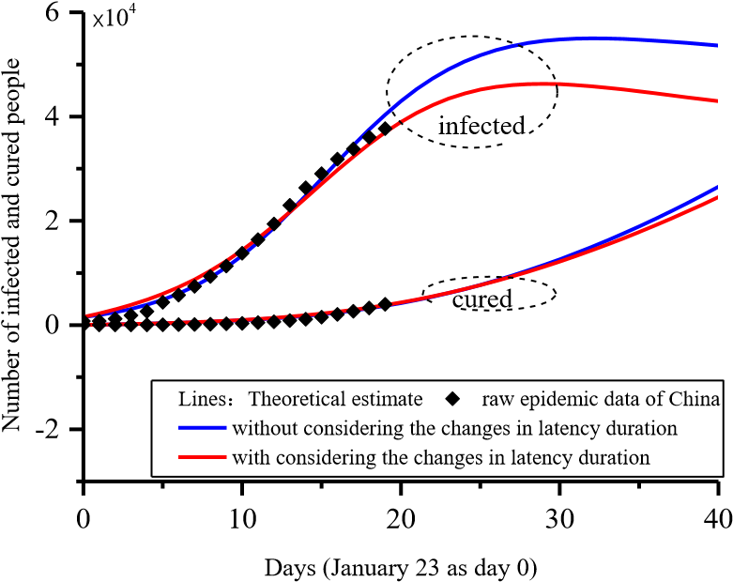

Fig.3. Impact of variation of incubation period length on the theoretical estimation.

Next, Figure 3 analyzes the effect of variation of incubation period length on the theoretical estimation. It can be seen from Fig. 3 that the peak number of infected persons in the model considering the variation of the incubation period is lower than that in the model with the constant incubation period. This corresponds to an easily understood fact. With the development of the epidemic, the length of the incubation period has shortened, which directly leads to the patients in the incubation period to show symptoms faster and be taken to hospital and quarantined. Therefore, the gradual shortening of the incubation period is obviously conducive to suppressing the spread of the epidemic, and eventually leading to a reduction in the peak number of infections.

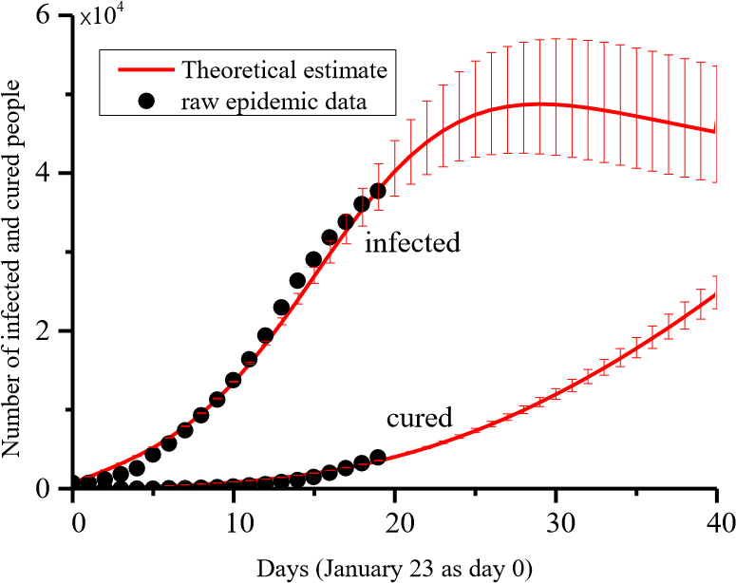

Fig. 4. Evaluation of the spread of China's 2019nCoV epidemic

Finally, the trend of China's 2019-nCoV epidemic was evaluated by using the new present SEIR model. In order to obtain an interval estimate of the peak number of infections and its occurrence time, the contact rate was set to vary within the interval of [2.8, 4.2]. The prediction of the current theoretical model indicates that the number of 2019-nCoV infections in China reaches its peak after February 19, and the upper and lower limits of the estimated peak time of the epidemic respectively correspond to the abscissa of the peaks of the upper and lower envelopes of the theoretical forecast data of the number of infected. The current theoretical estimation of the number of infected people in China is in good agreement with the raw number of infected people in the period from January 23, 2020 to February 10, 2020. It is worth noting that the theoretical model and parameters of this paper were initially established before February 5. The prediction results of the number of infected persons from February 6 to February 10 are mainly consistent with the actual data of subsequent reports, which initially proves the feasibility of the model in predicting the short-term development situation of the epidemic.

This paper attempts to estimate the short-term development of China's 2019-nCoV epidemic and predicts that the number of people infected in China will peak after February 19. It should be noted that because the infectious ability of patient in latent period and variation of incubation period length are considered, our present model in this paper is closer to the real situation, so the estimates based on it should also be more reliable. However, some necessary assumptions are still made during the model establishment in this paper. The mathematical descriptions made by the model are different from the complex reality, which leads to the inevitable deviation of the prediction results.

This work was financially supported by the National Natural Science Foundation of China (No. 11802225).